

**IMC Ramkrishna Bajaj National Quality Award Trust  
Registration Form**

|  |
| --- |
| Understanding the IMC RBNQ Award Criteria  Date: 8 May 2019  Time: 3.00pm to 5.00 pm  Duration: 2 hours  Venue: IMC Conference room 601/602, 6th Floor, Commodity Exchange Bldg,  Sector 19-A, Vashi, Navi Mumbai 400705  *\*Complimentary*  *Yes* |

|  |  |
| --- | --- |
| Details: | |
| 1. Organization Name:  _____________________________________________________________________________ | |
| 2. Address:  ____________________________________________________________________________  ____________________________________________________________________________  ____________________________________________________________________________  ___________________________________________________________________________ | |
| 3. Participants: |  |
| Name:____________________________  Cell:__________________________ | Designation: ______________________________  Email: ___________________________________ |
|  |  |
| Name:___________________________  Cell:__________________________ | Designation: ______________________________  Email: ___________________________________ |

**Contact: Mr. Anil Panchal, Asst. Director**

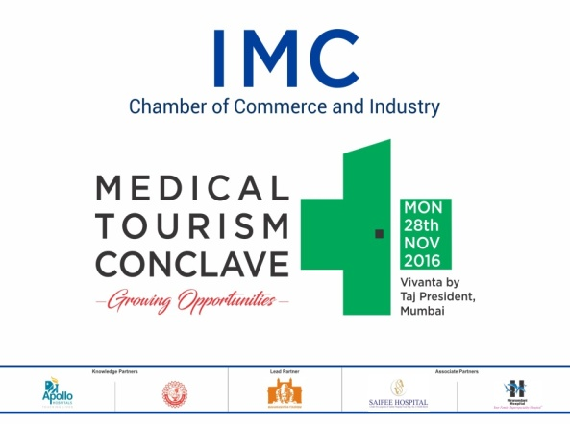 IMC Chamber of Commerce and Industry, Vashi Branch

Tel: (022) 22025438, 27842466

Email: imcvashi@imcnet.org/excellence@imcrbnqa.com

**Website: www.imcrbnqa.com**